AIRLINE TICKET BOOKING SYSTEM

BY: KOMAL AVINASH SINHA

Tables Used:

1. admin

2. flight

3. passenger

4. booking

There are basically two main pages:

home.jsp

This page is basically for users.

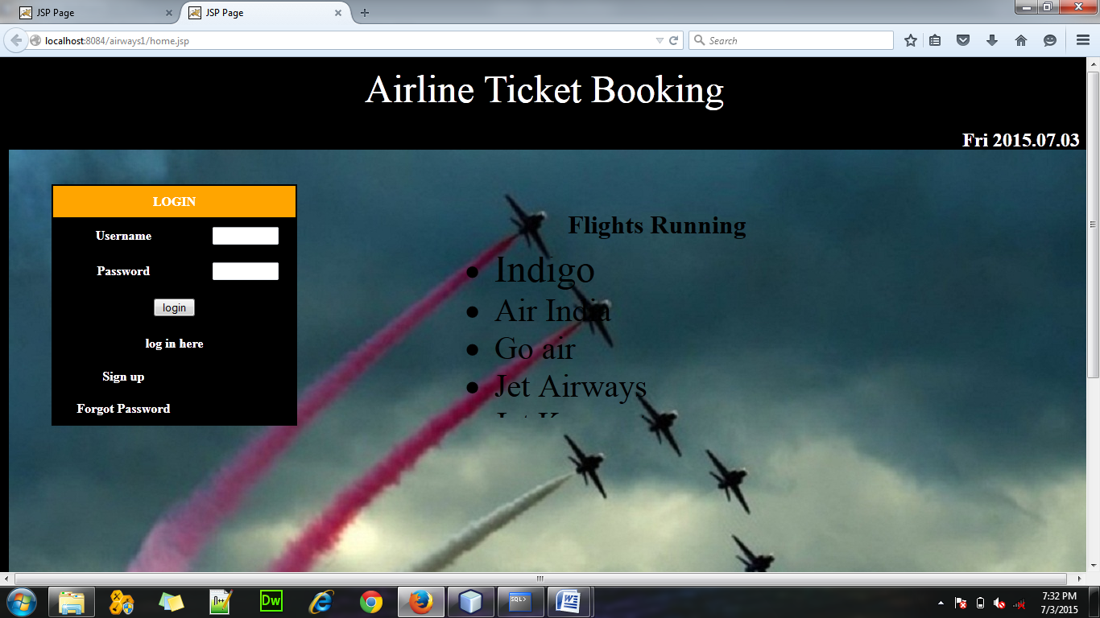

Customer has to first make his account before he can go with the login process and book tickets.

On clicking the Sign up link the following page will open.

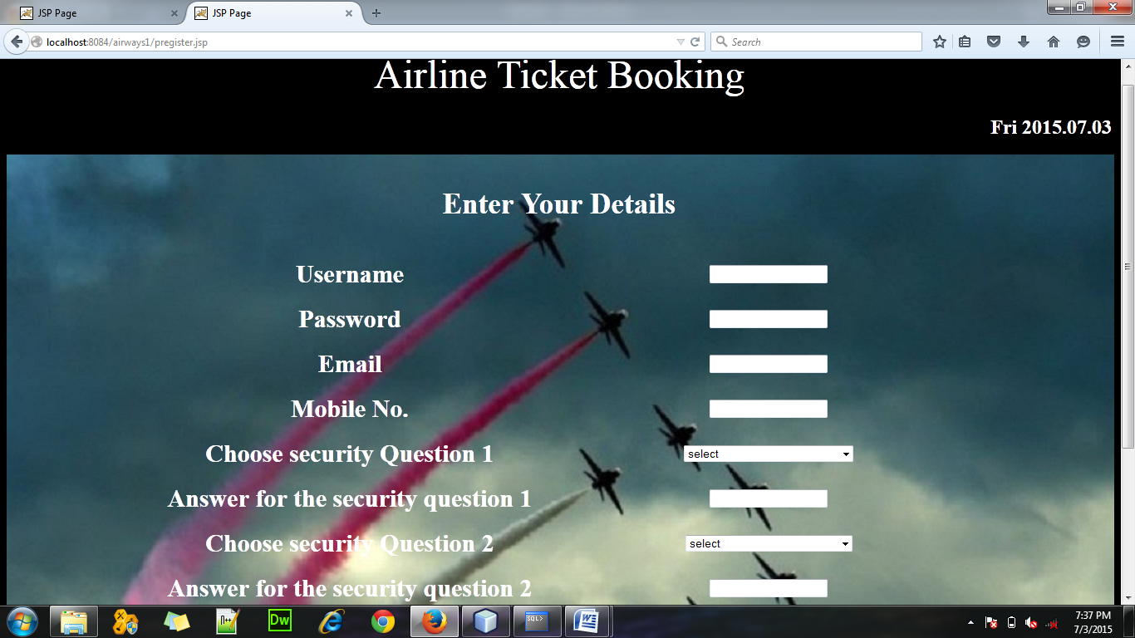

Through this page a customer can make his/her account by filling in the details.

After the registration is successful , one can login with username and password.

In case, the user forgets his/her password he/she can click on “Forgot Password” link on home.jsp

On clicking it, the following page opens.

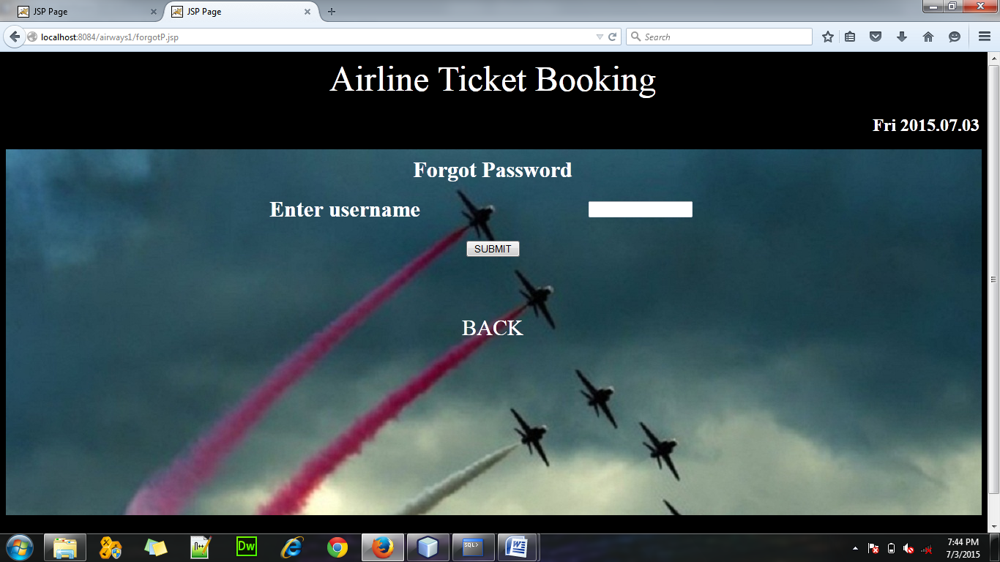

Here the user has to enter the username with which he is operating his account. Then ,he will be asked to answer the 2 security questions he chose while creating his account. If he answers correctly, then he can set a new password. If he fails in answering , then he has no other option besides creating a new account.

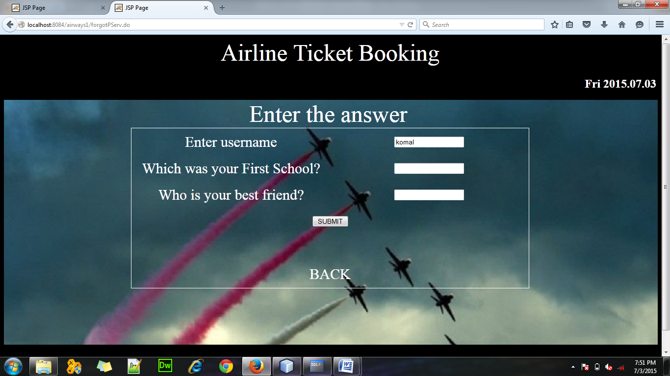

If the user logins successfully, then cpage.jsp will open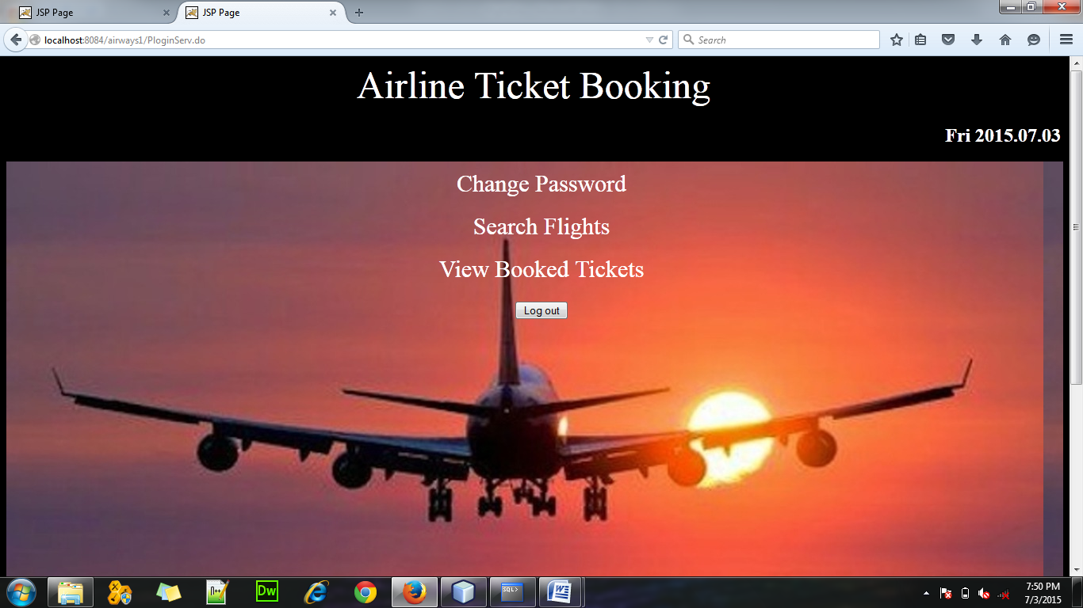

Here user can :

Change password.

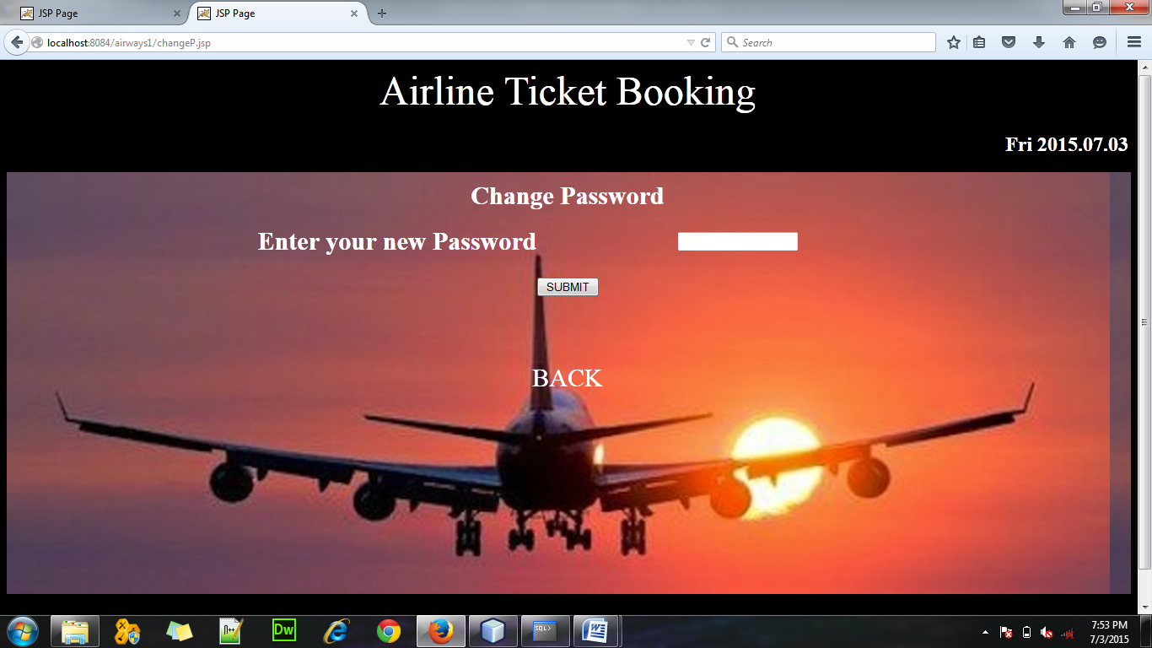

Search Flights:

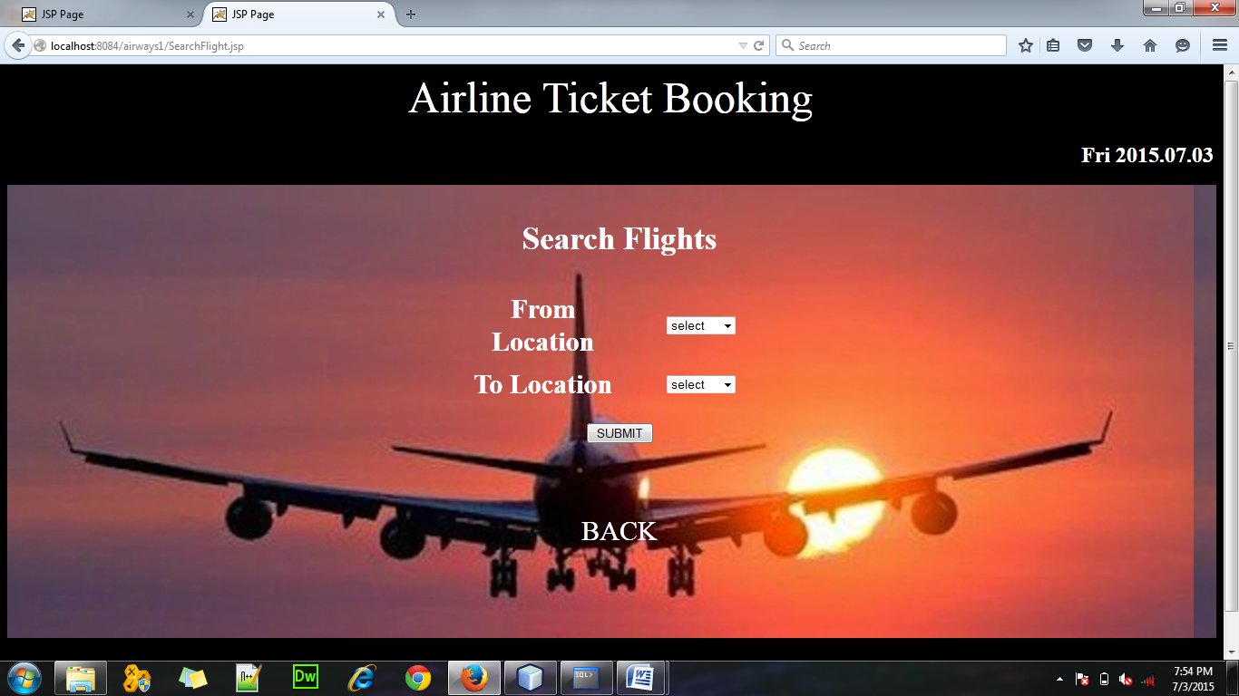

After entering the location , flights available will be shown.

For example, if a enter Kolkata in from location and Mumbai in to location, then following page opens.

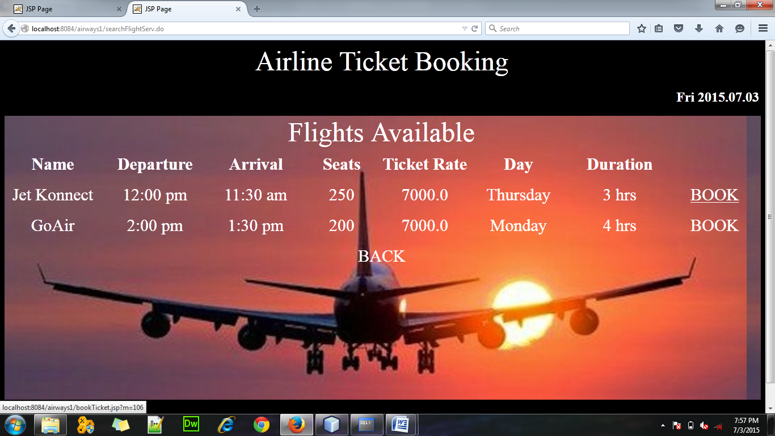

Here, on clicking the “BOOK” link “bookTicket.jsp” opens wherein you can fill the details and book ticket.

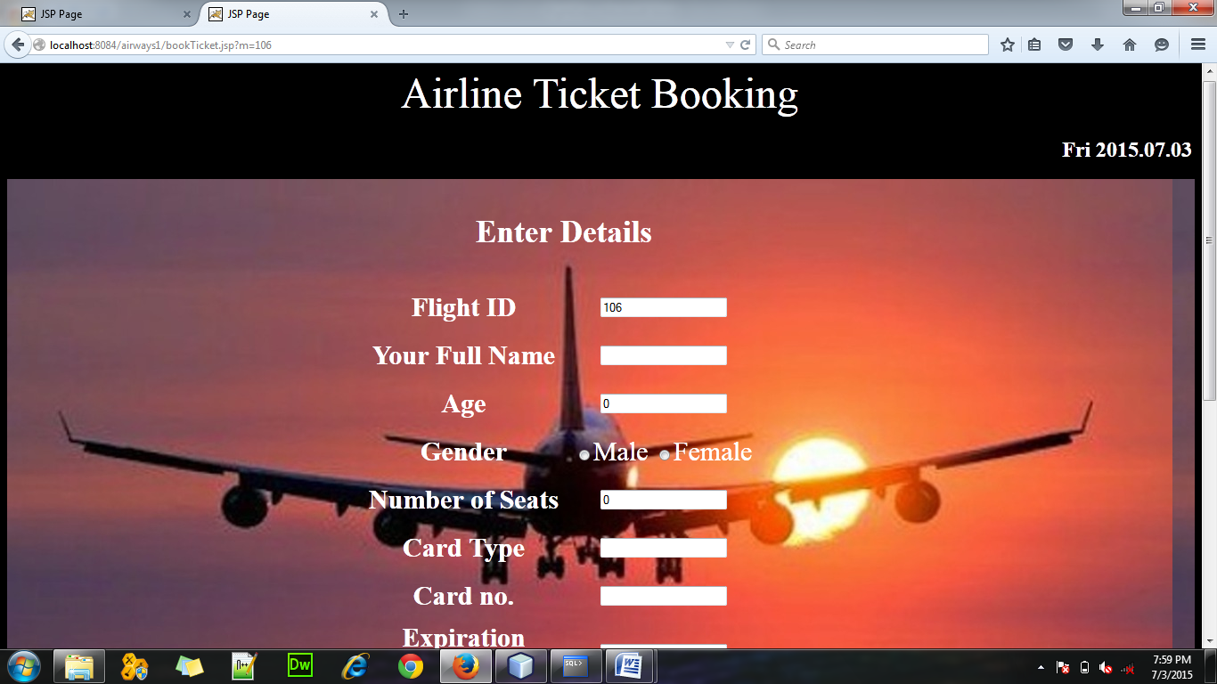

View Booked Tickets:

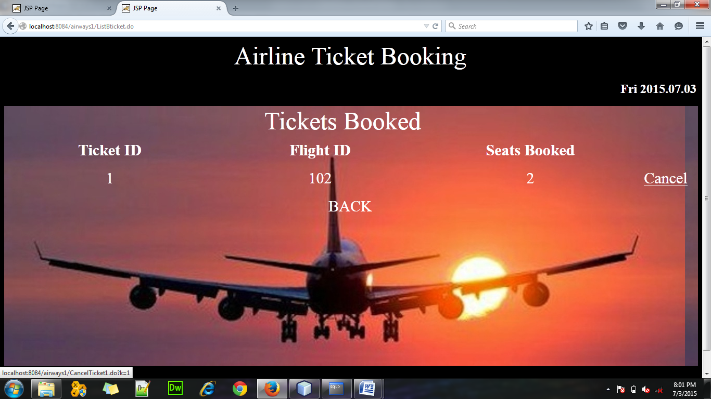

Here the user can view the tickets he has already booked and in case he wants to cancel the ticket he can click on the Cancel link.

As for example, I have booked 2 seats in GoAir(Flight id- 102).

Admin Page:

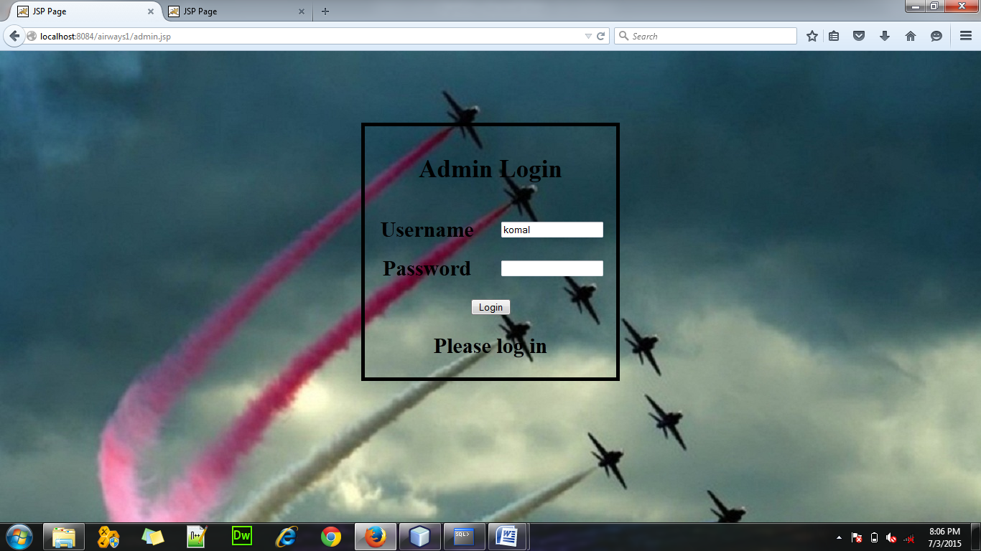

After logging in adminPage.jsp will open.

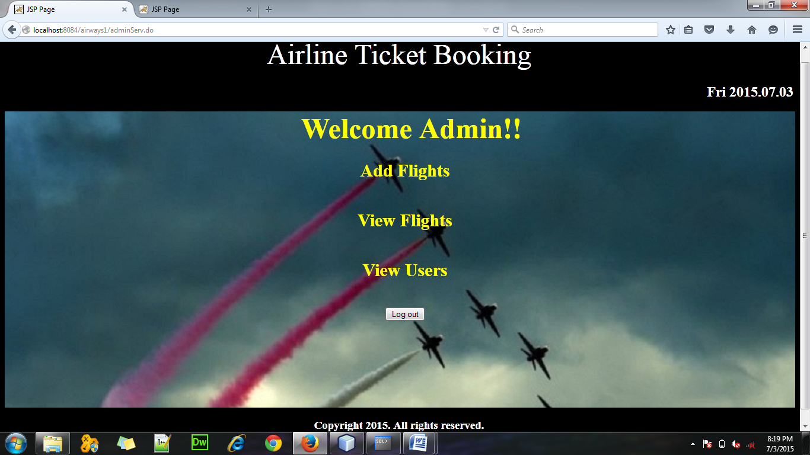

The admin can Add Flights:

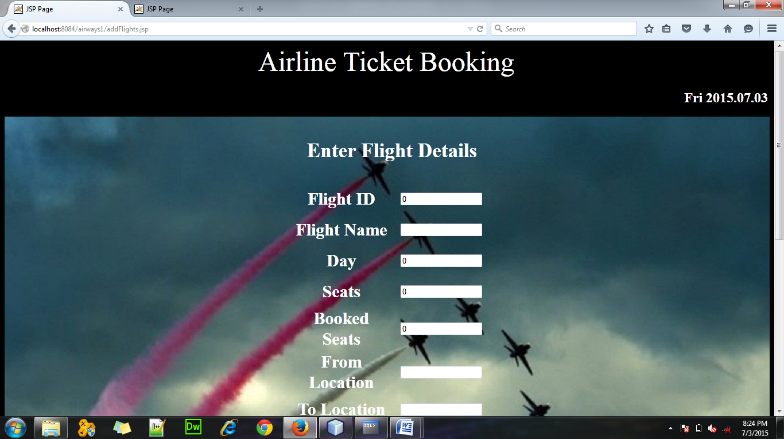

He can view flights:

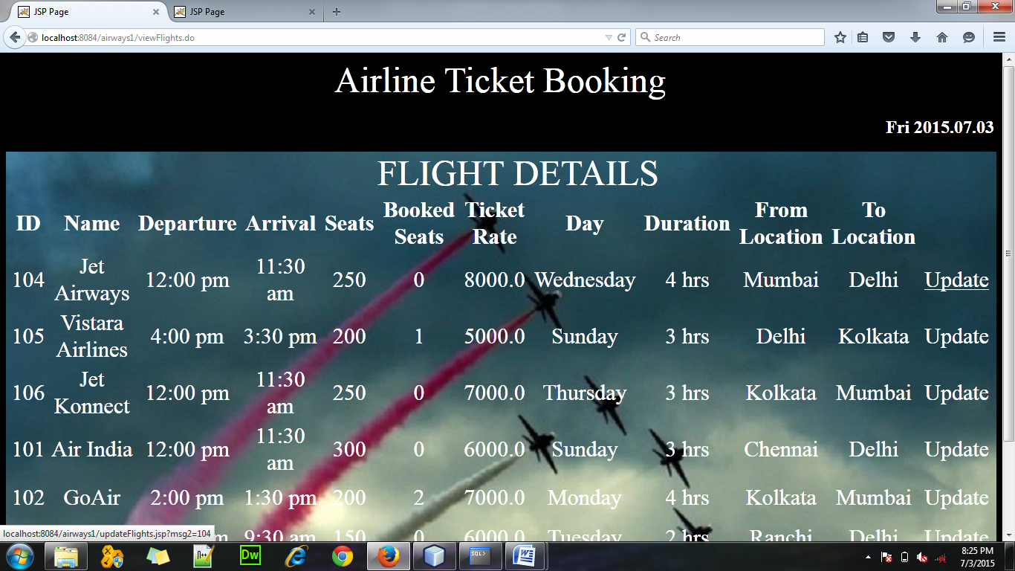

On clicking the update link he can update the flight details.

He can also view users by clicking on “View Users” link.

